**Introduction:**

In this lab, we used electromyography (EMG) signals to investigate muscle activity in the biceps and triceps muscles. The purpose of this lab was to explore the effects of different stimuli on muscle activity in the biceps and triceps muscles. To collect the EMG data, we used Biopac amplifiers to record electrical activity from the biceps and triceps muscles. We also used MATLAB to analyze the recorded signals and extract meaningful information.

**Materials:**

* Biopac amplifier
* Electrodes
* Medical tape

**Methods:**

The first part of the lab had us press on the bottom of the table, resting in between for short intervals in order to activate and deactivate the biceps brachii muscle. The Biopac amplifier has the ability to prefilter data, and data was recorded using each of the prefilter options, a104, a108, and a111.

The second part of the lab had us grab the edge of the table and alternate pressing up and down to activate the biceps and triceps alternately with moderate force. This section required using prefilter a111.

The final part of the lab had us grab the edge of the table like in the second part, but alternately push with maximum force. This section also required prefiltering with a111.

**Results:**

**Experiment A:**

Signal Analysis

Power Spectrums in signalAnalyzer:

Filter A104 (blue), Filter A108 (red), Filter A111 (yellow)

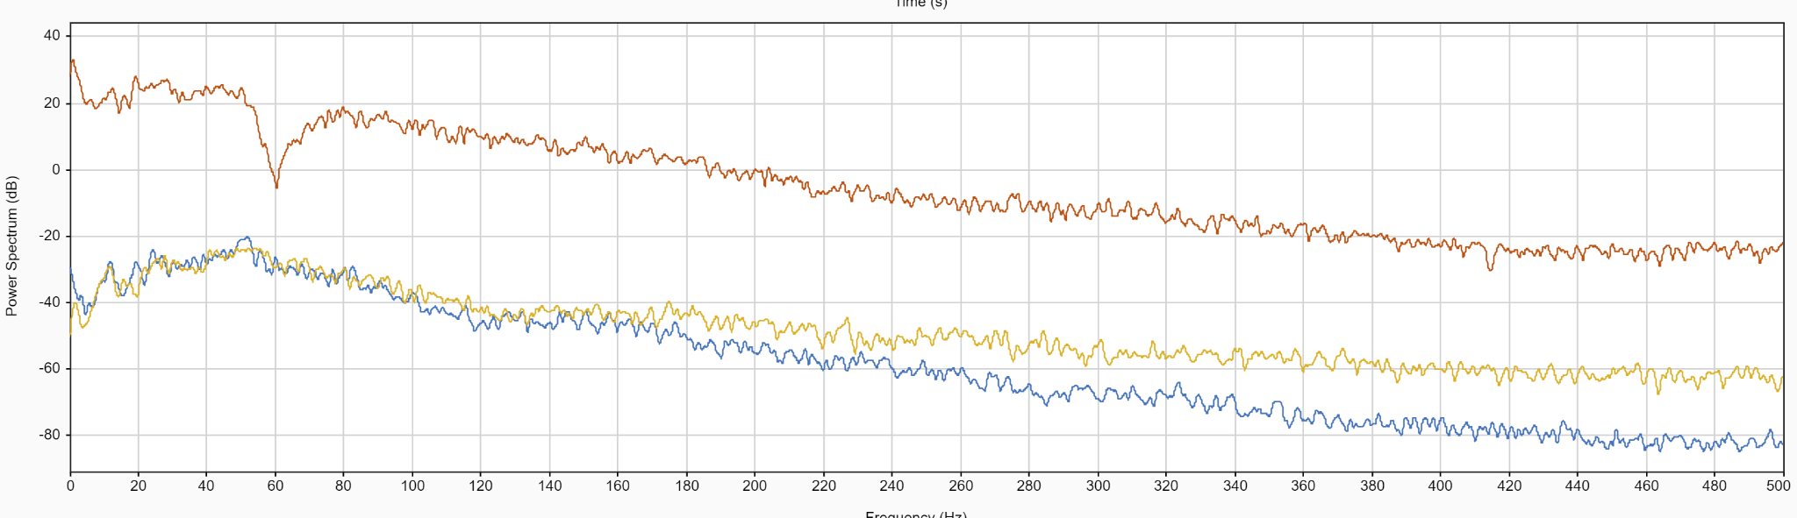

There is a dip at 60 hz in the Filter A108, which was part of the prefiltering to avoid noise from ambient electrical devices. The dip was likely a result of overcompensating by the filter.

Filtering

Filter the a111 precept using butter and filtfilt with high pass and low pass:

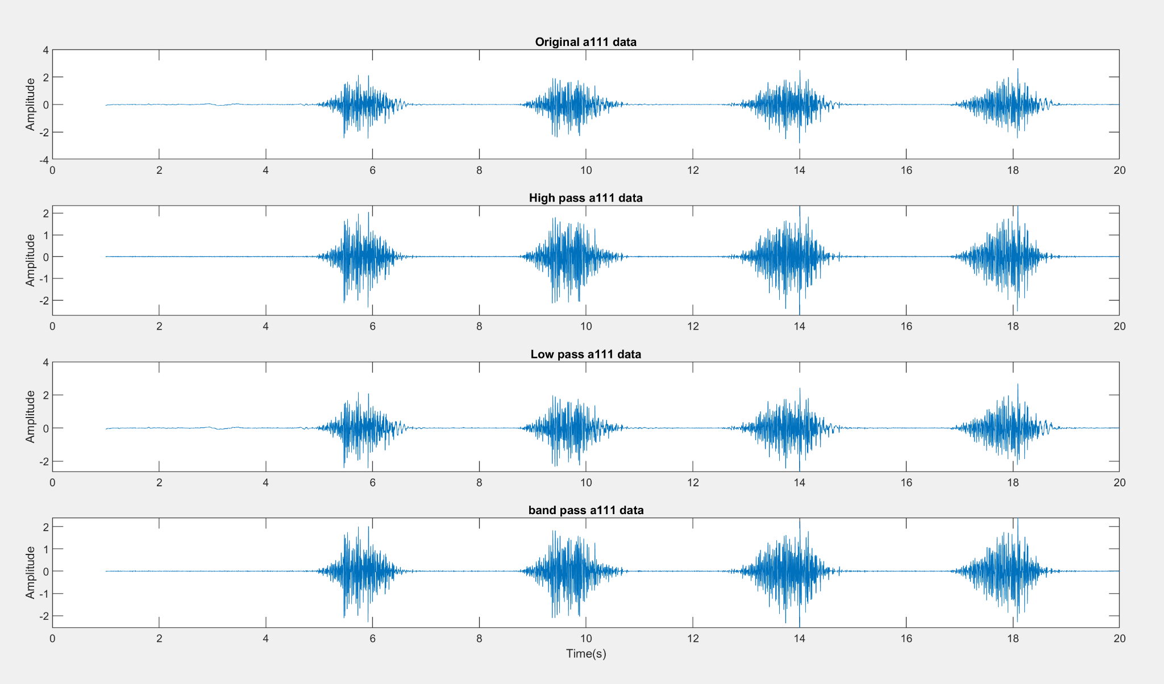

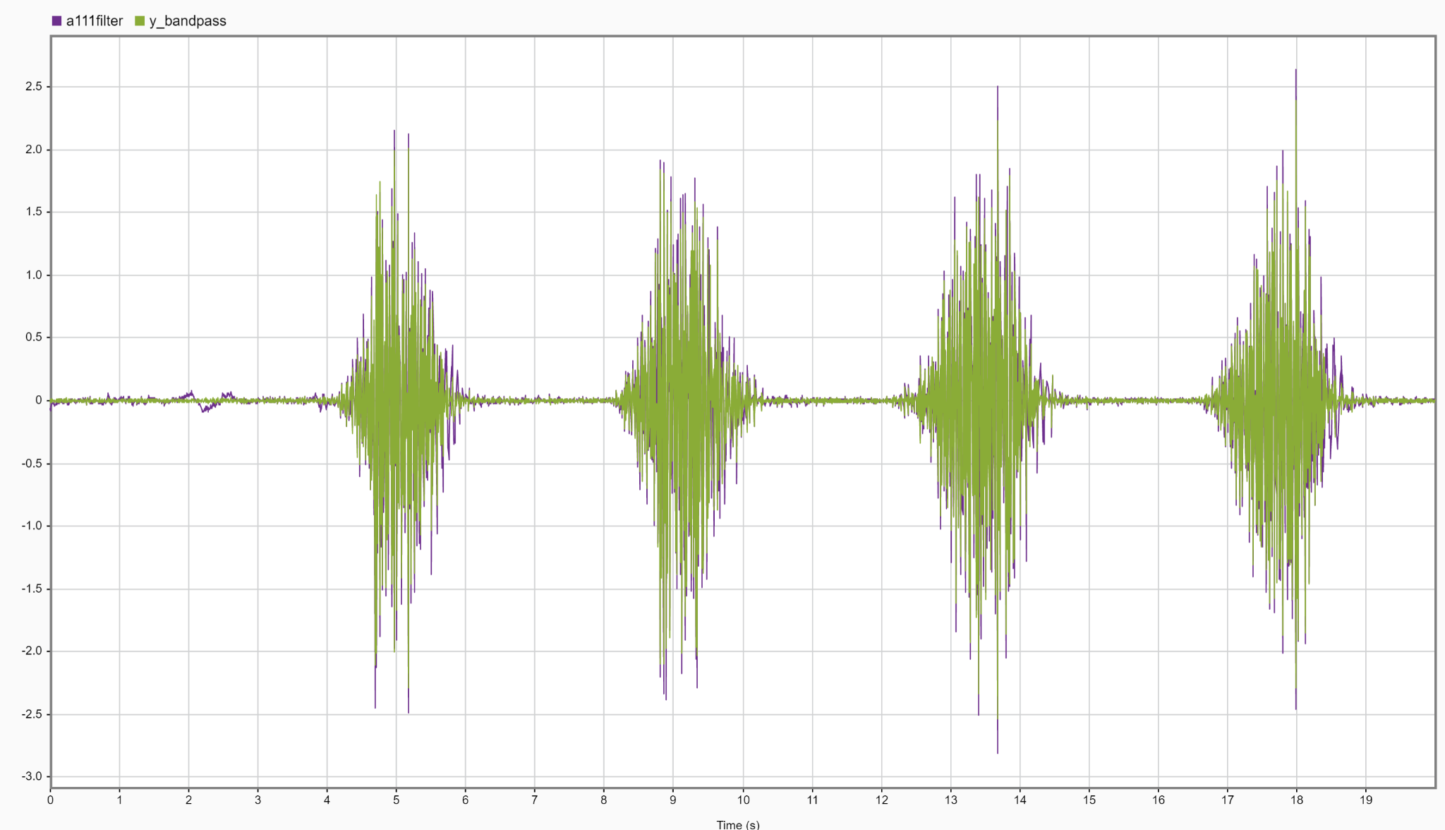

As seen in the signalAnalyzer view above, the original data (purple) has noise in the first 2 to 3 seconds, which is mostly eliminated by the bandpass filter (green). The majority of this filtering was done by the high pass component at 20Hz, because for EMG signals, low frequencies are considered noise, and high frequencies are typically part of the signal.

Rectified filtered a111 data:

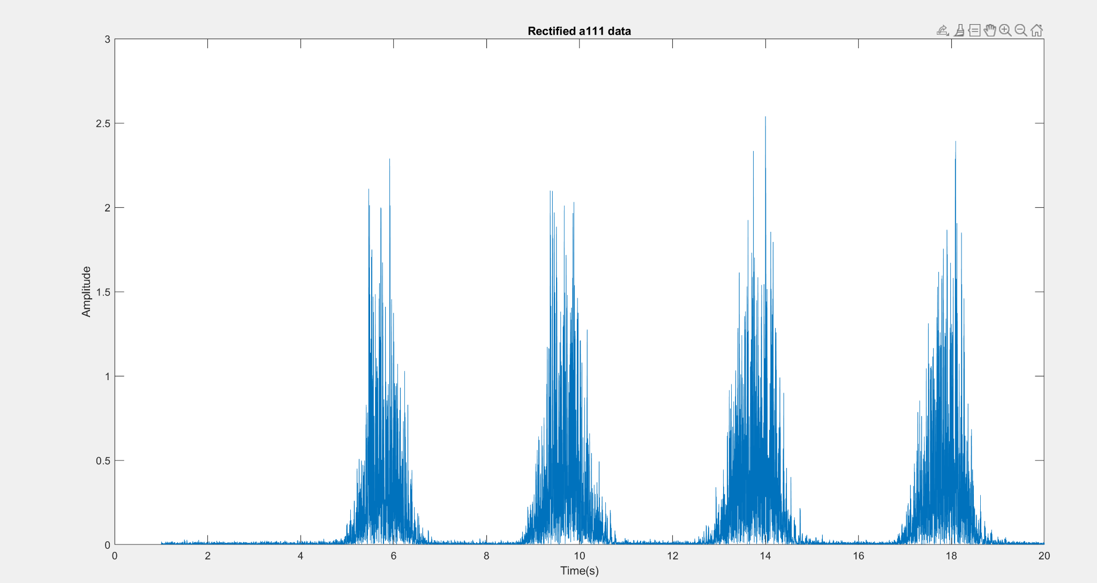

Rectified original and filtered data:

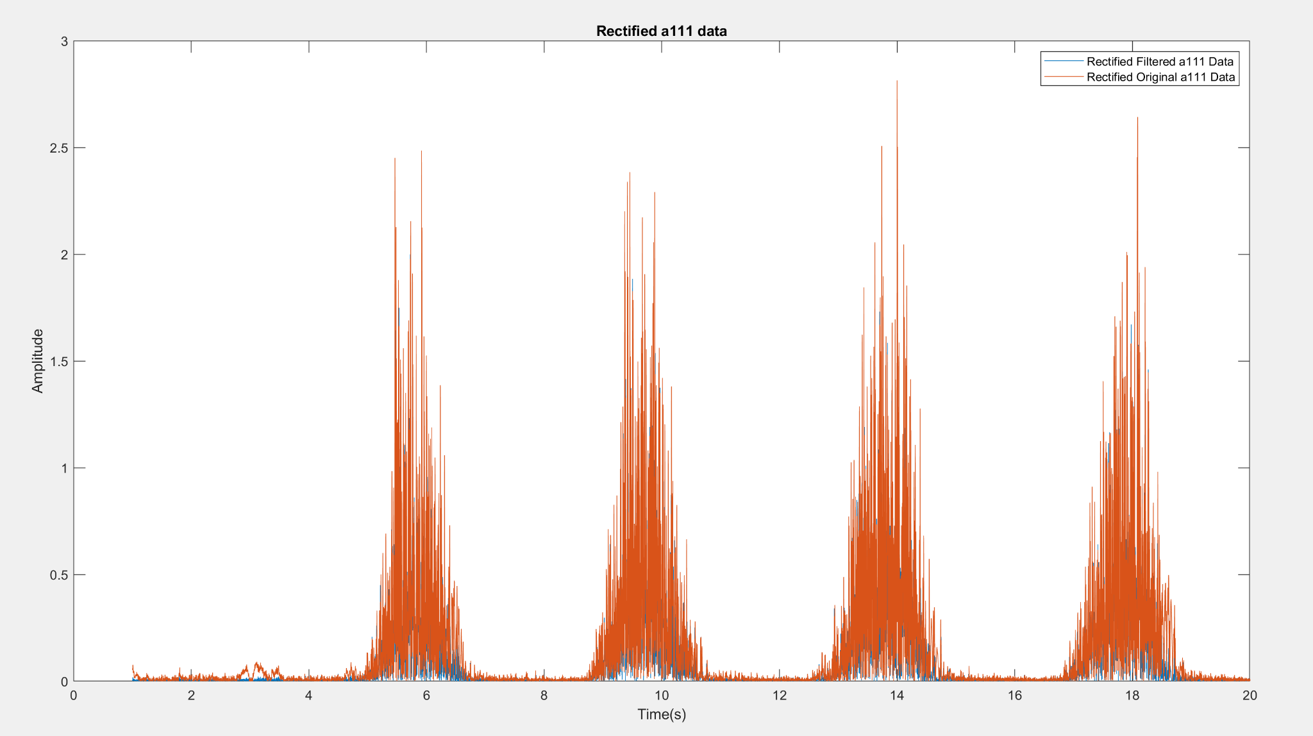

Rectified A111 Data with envelope and moving mean:

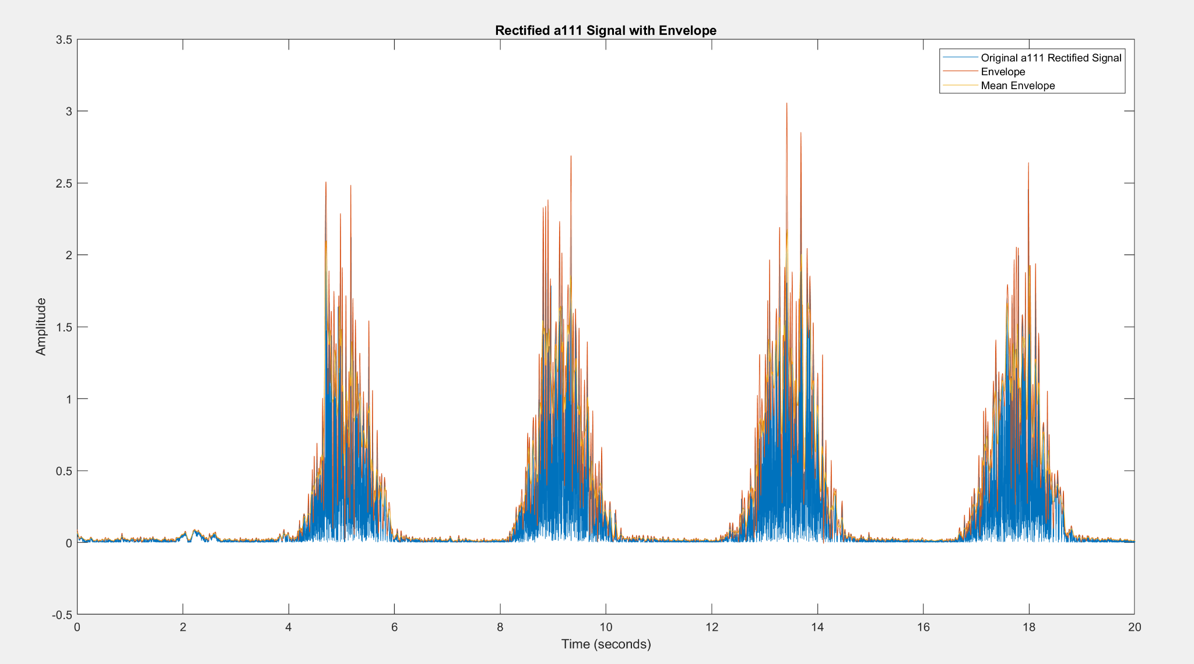

Rectified A104 Envelope and moving mean:

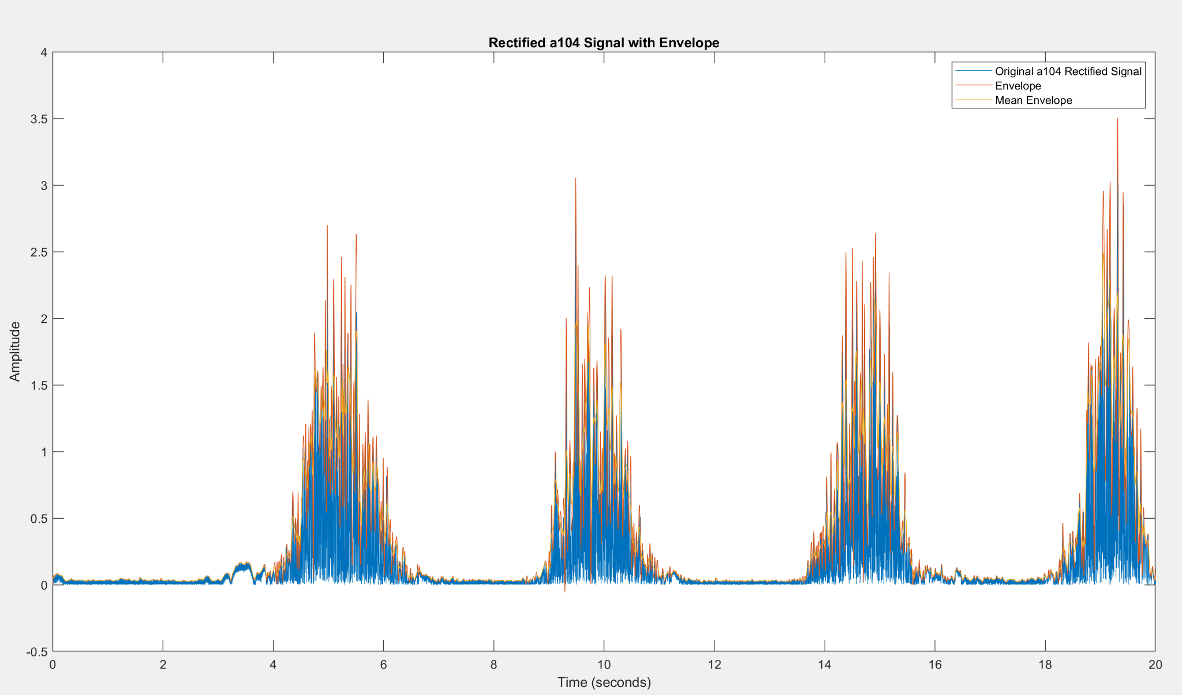

Rectified A108 Envelope and moving mean:

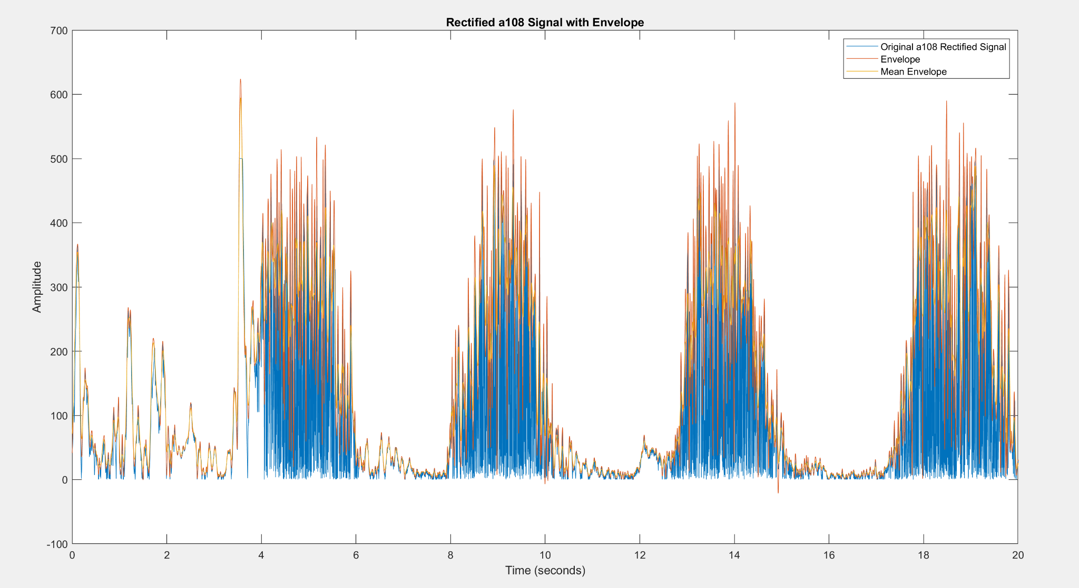

**Experiment B:**

This is the graph of the original, low pass, and high pass filters for the bicep and tricep

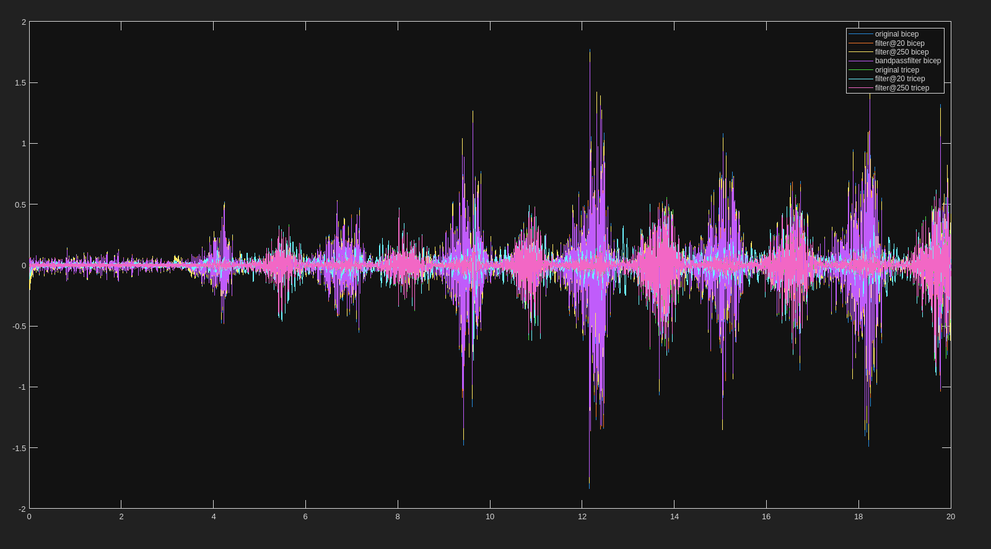

This is the graph of the original, low pass, and high pass filters for the bicep separately:

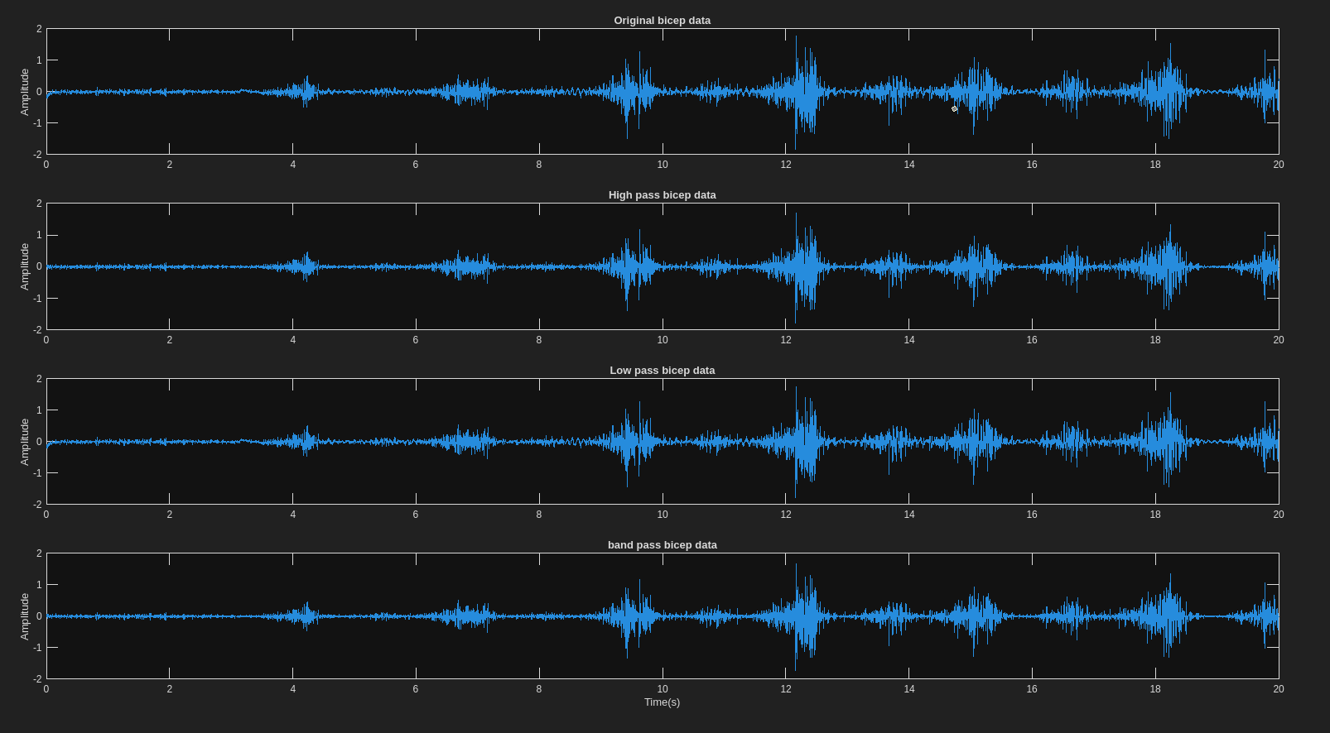

This is the graph of the original, low pass, and high pass filters for the tricep separately:

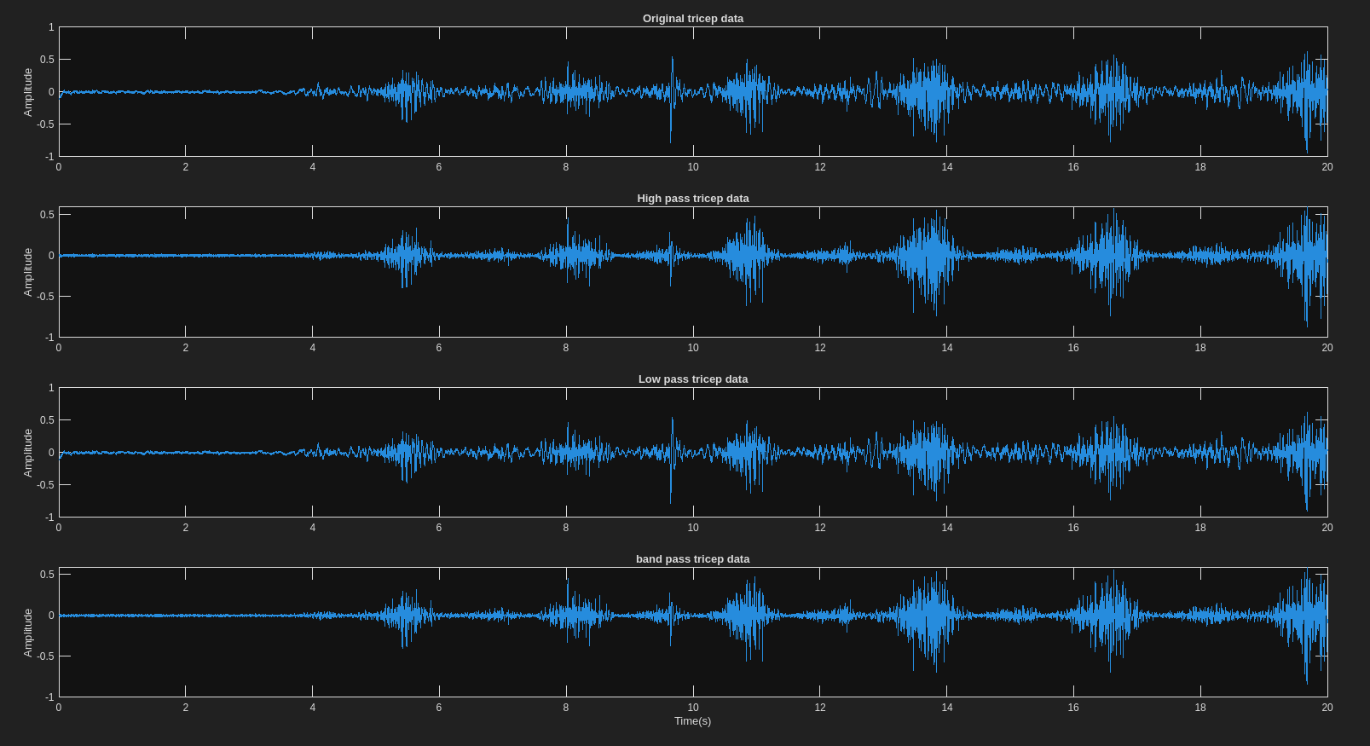

This is the graph of the rectified original and filtered graphs for both the biceps and triceps

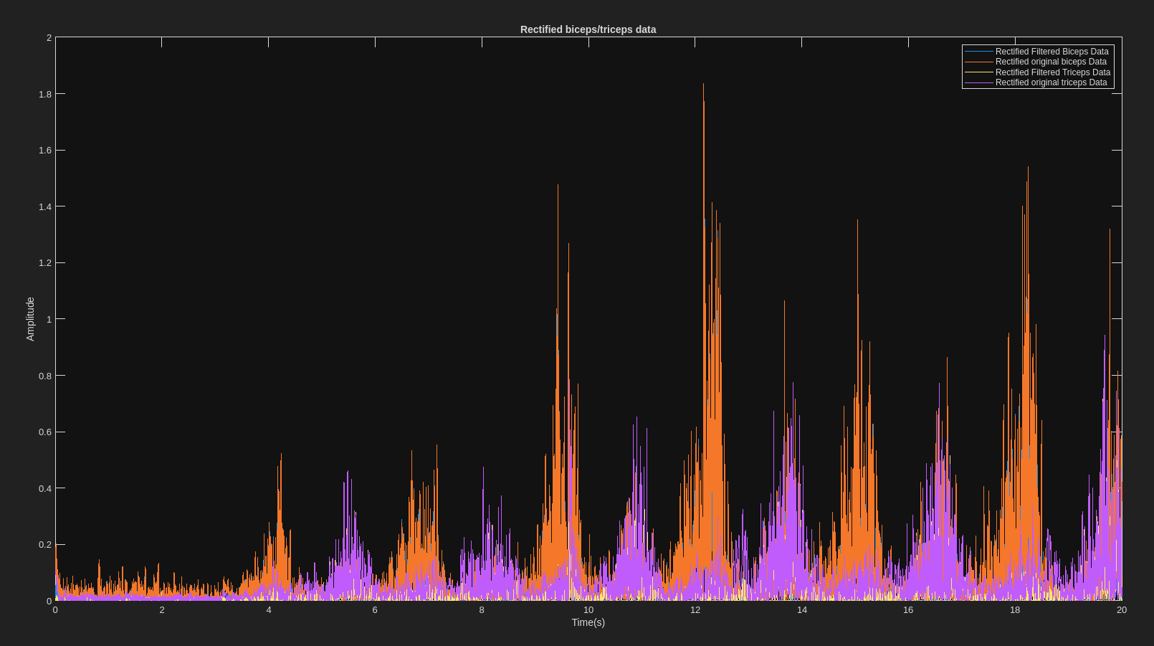

This is the graph of the rectified signals for the biceps and triceps, the envelopes, and mean envelopes.

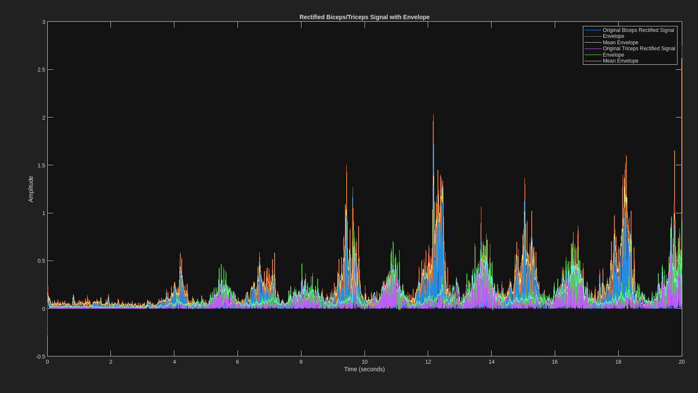

**Experiment C:**

This is the graph of the original, low pass, and high pass filters for the bicep and tricep

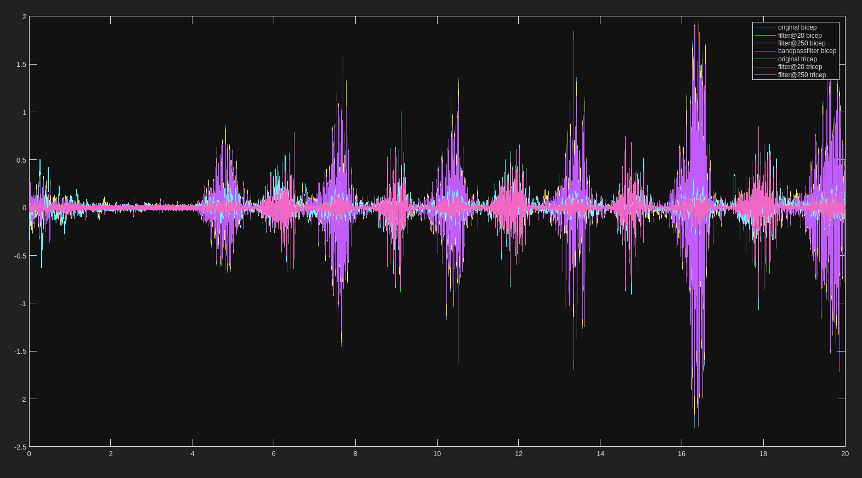

This is the graph of the original, low pass, and high pass filters for the bicep separately:

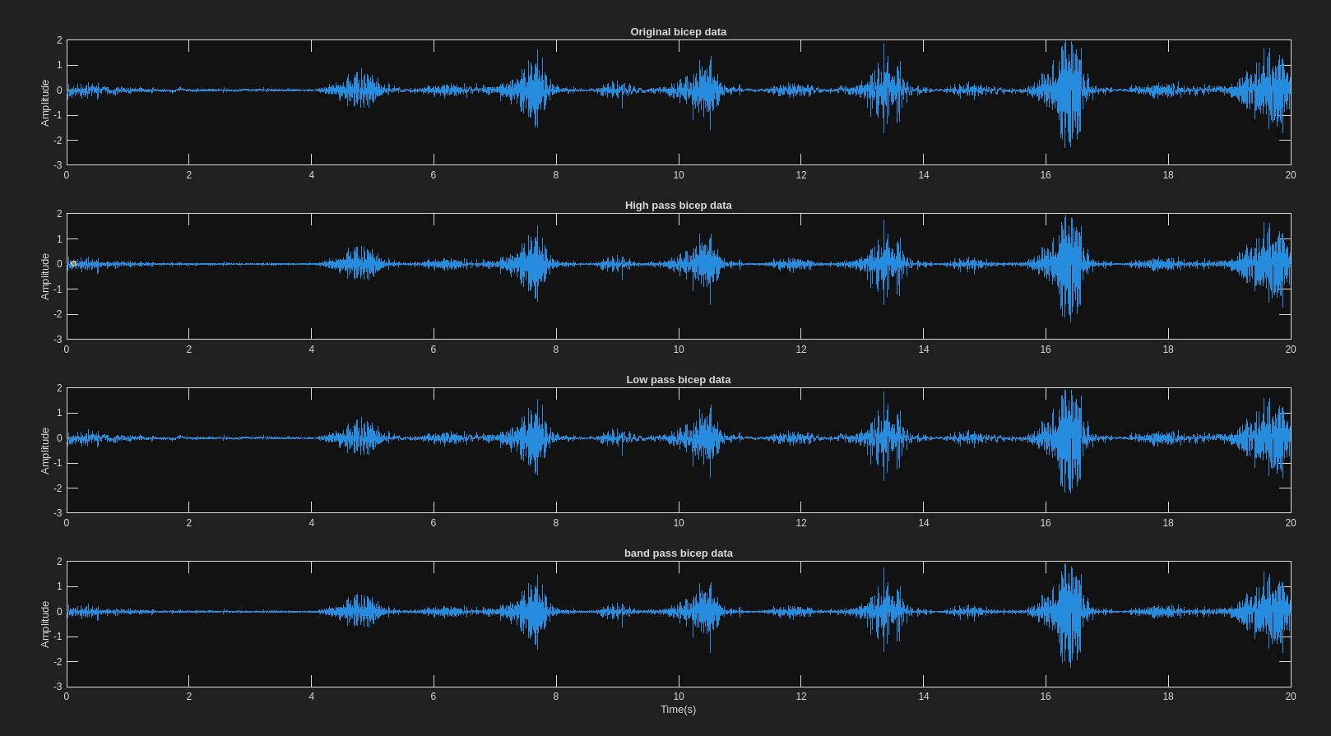

This is the graph of the original, low pass, and high pass filters for the tricep separately:

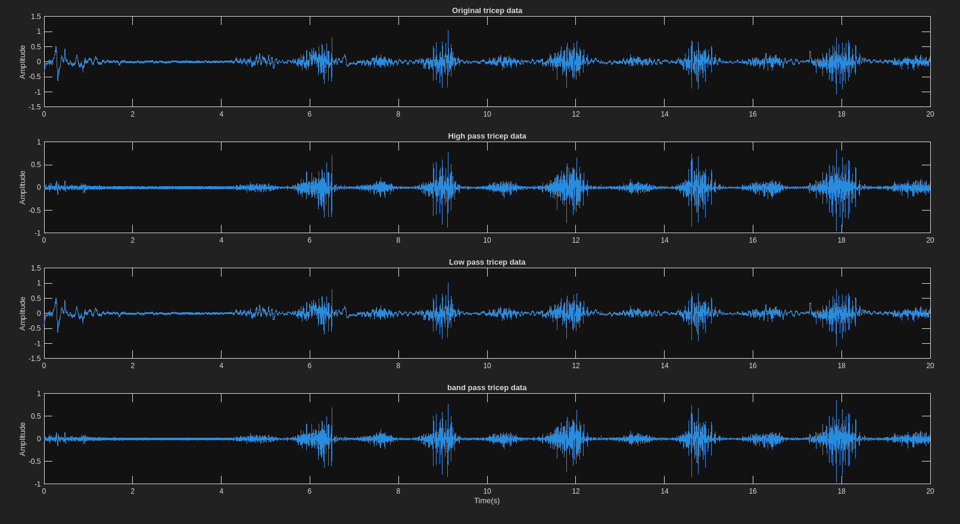

This is the graph of the rectified original and filtered graphs for both the biceps and triceps

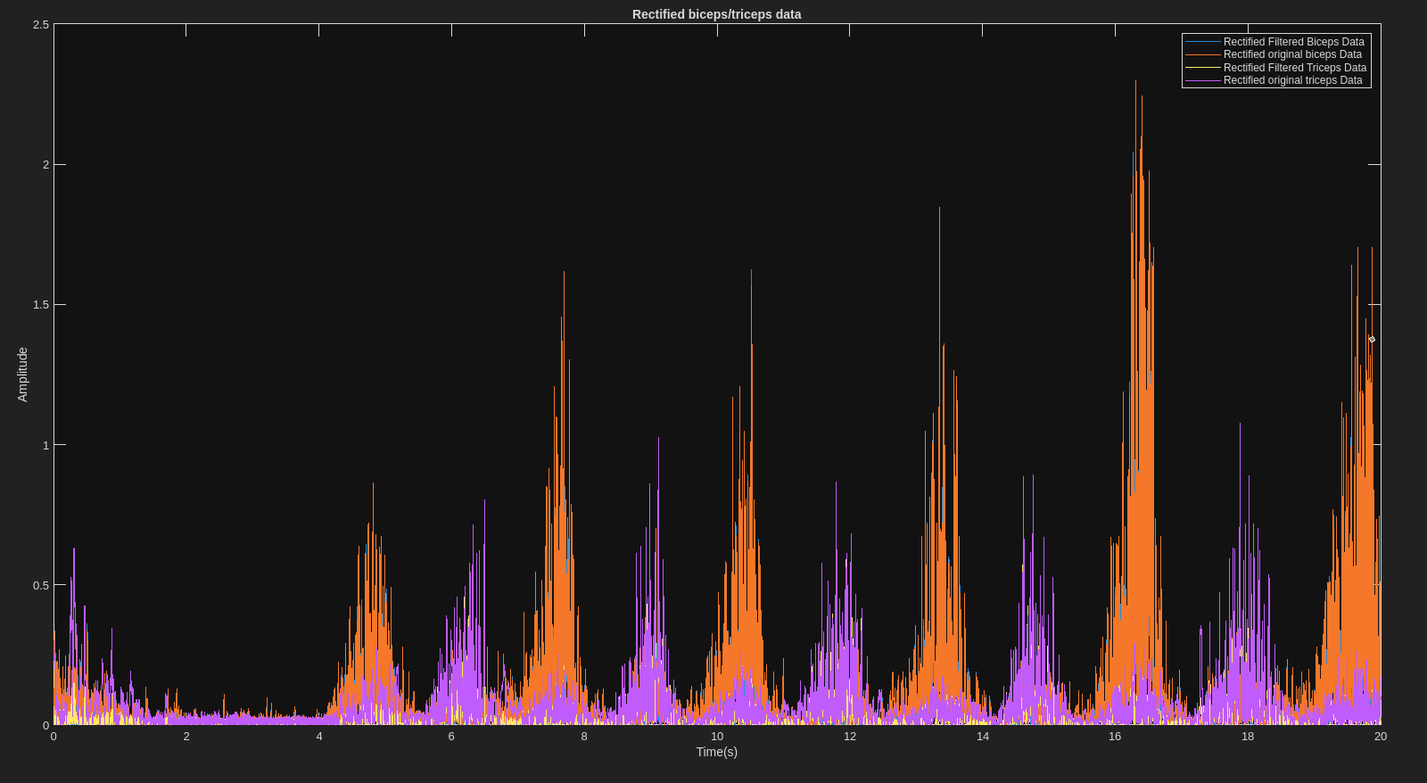

This is the graph of the rectified signals for the biceps and triceps, the envelopes, and mean envelopes.

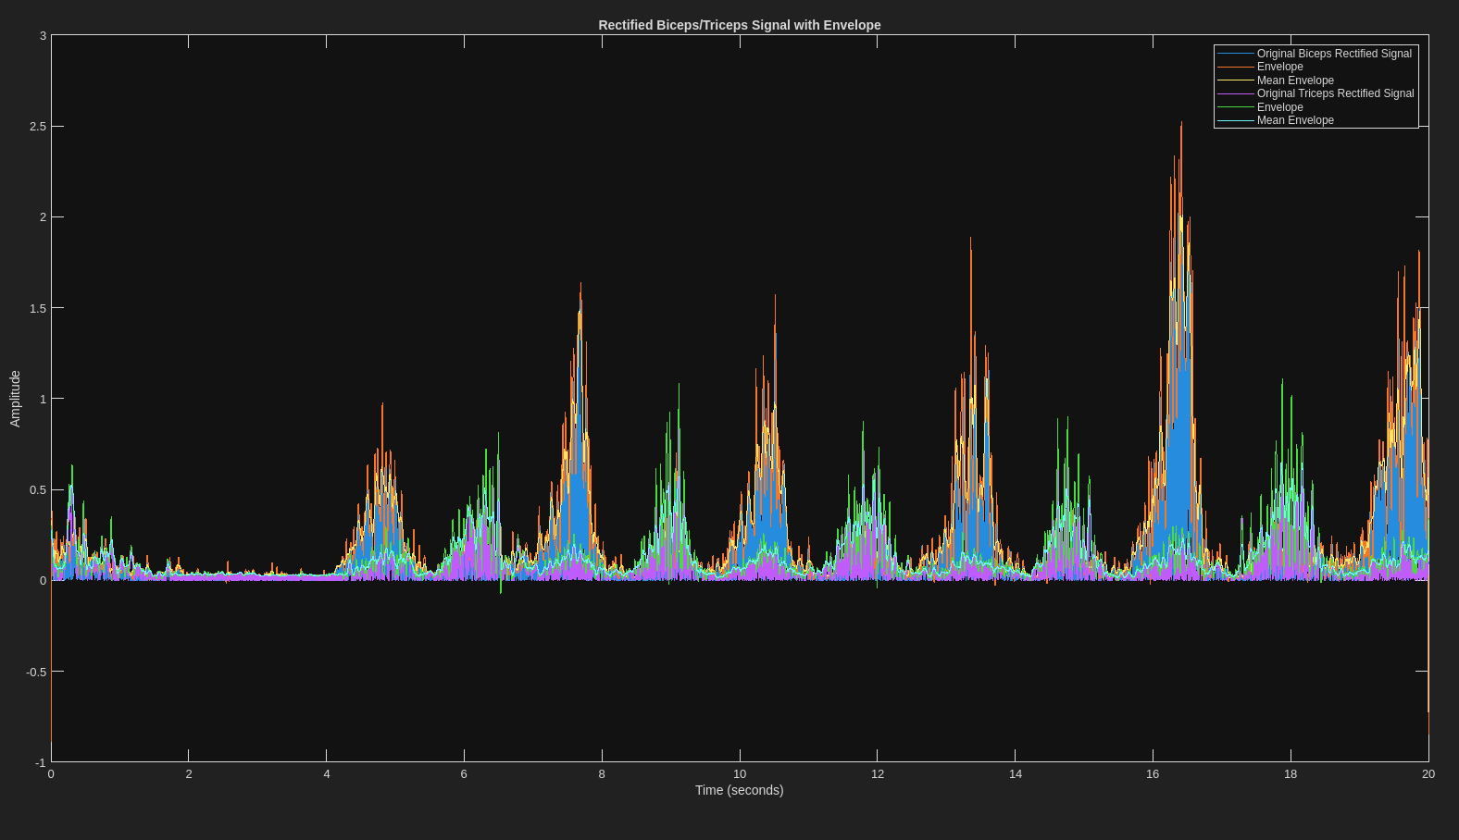

Comparing onset of biceps between moderate and maximum:

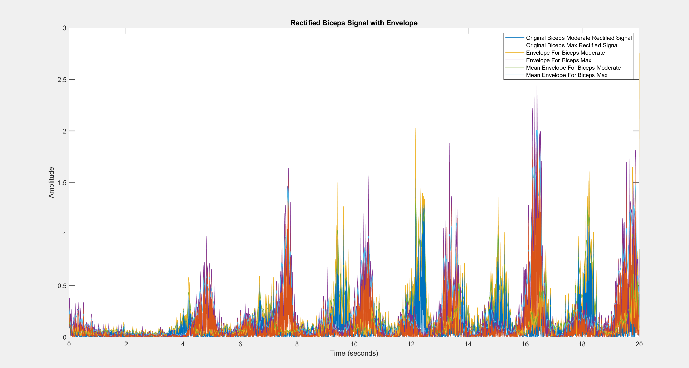

Comparing onset of triceps between moderate and maximum:

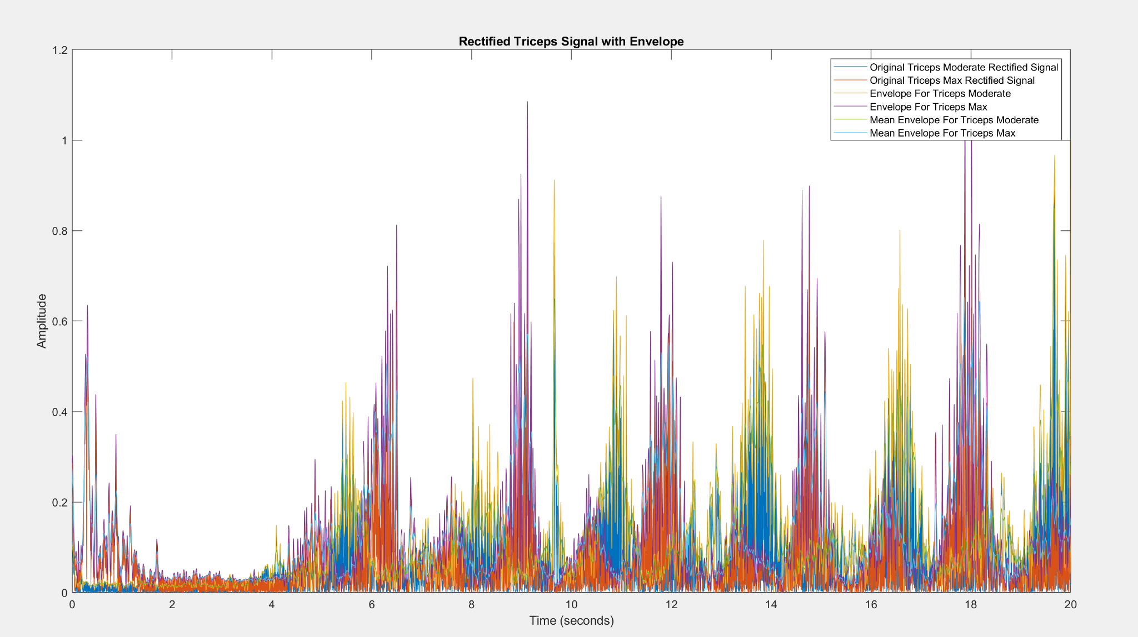

Matlab code:

%% loading initial stuff

clc;

clear variables;

close all;

load experimenta104.mat

a104filter = ch1data;

load experimenta108.mat

a108filter = ch1data;

load experimenta111.mat

a111filter = ch1data;

clear ch1data

time = linspace(0,20,20000);

%original

figure

plot(time,a111filter)

hold on;

%plot(time, data2array)

SF = 1000;

order = 2;

%filter at 20

cutoff_freq = 20/500;

[b, a] = butter(order, cutoff_freq, "high");

y = filtfilt(b, a, a111filter);

plot(time,y)

%filter at 250

cutoff_freq2 = 250/500;

[b2, a2] = butter(order, cutoff_freq2, "low");

y2 = filtfilt(b2, a2, a111filter);

plot(time,y2)

y_bandpass = filtfilt(b2, a2, y);

plot(time,y_bandpass)

legend('original', 'filter@20', "filter@250",'bandpassfilter')

figure

subplot(4,1,1);

plot(time, a111filter);

title('Original a111 data')

ylabel('Amplitude')

subplot(4,1,2);

plot(time, y);

title('High pass a111 data')

ylabel('Amplitude')

subplot(4,1,3);

plot(time,y2);

title('Low pass a111 data')

ylabel('Amplitude')

subplot(4,1,4)

plot(time,y_bandpass);

title('band pass a111 data')

ylabel('Amplitude')

xlabel('Time(s)')

%%

yabsfilt = abs(y_bandpass);

yabs = abs(a111filter);

figure

plot(time,yabsfilt)

hold on

plot(time, yabs)

title('Rectified a111 data')

xlabel('Time(s)')

ylabel('Amplitude')

legend('Rectified Filtered a111 Data', 'Rectified Original a111 Data')

%% Envelope and Analysis

% Use the 'envelope' function to get the upper envelope of the signal

[Env, lowerEnv] = envelope(yabs, round(1000*0.01), 'peak'); % 'round(Fs*0.01)' is an example window length for peak detection

% Calculate the moving mean for the upper envelope

Envmean = movmean(abs(Env), 50);

% Plot the original signal

figure

plot(time, yabs);

hold on; % Allows plotting multiple data sets on the same figure

% Overlay the envelope on the same plot

plot(time, Env); % Plots the upper envelope with a thicker line

plot(time, Envmean)

% xlim([1 7])

% ylim([-0.5 3])

hold off;

xlabel('Time (seconds)');

ylabel('Amplitude');

title('Rectified a111 Signal with Envelope');

legend('Original a111 Rectified Signal', 'Envelope', 'Mean Envelope');

%%

time = linspace(0,20,20000);

yabs = abs(a104filter);

% Use the 'envelope' function to get the upper envelope of the signal

[Env, lowerEnv] = envelope(yabs, round(1000*0.01), 'peak'); % 'round(Fs*0.01)' is an example window length for peak detection

% Calculate the moving mean for the upper envelope

Envmean = movmean(abs(Env), 50);

% Plot the original signal

figure

plot(time, yabs);

hold on; % Allows plotting multiple data sets on the same figure

% Overlay the envelope on the same plot

plot(time, Env); % Plots the upper envelope with a thicker line

plot(time, Envmean)

% xlim([1 7])

% ylim([-0.5 3])

hold off;

xlabel('Time (seconds)');

ylabel('Amplitude');

title('Rectified a104 Signal with Envelope');

legend('Original a104 Rectified Signal', 'Envelope', 'Mean Envelope');

%%

yabs = abs(a108filter);

% Use the 'envelope' function to get the upper envelope of the signal

[Env, lowerEnv] = envelope(yabs, round(1000*0.01), 'peak'); % 'round(Fs*0.01)' is an example window length for peak detection

% Calculate the moving mean for the upper envelope

Envmean = movmean(abs(Env), 50);

% Plot the original signal

figure

plot(time, yabs);

hold on; % Allows plotting multiple data sets on the same figure

% Overlay the envelope on the same plot

plot(time, Env); % Plots the upper envelope with a thicker line

plot(time, Envmean)

xlim([0 7])

hold off;

xlabel('Time (seconds)');

ylabel('Amplitude');

title('Rectified a108 Signal with Envelope');

legend('Original a108 Rectified Signal', 'Envelope', 'Mean Envelope');

%% Same thing for Experiment B

% loading up new data:

load experimentb111-bicep.mat

bbicep = ch1data;

load experimentb111-tricep.mat

btricep = ch2data;

clear ch1data

clear ch2data

%original

%%figure

plot(time,bbicep)

hold on;

SF = 1000;

order = 2;

%filter at 20 bicep

cutoff_freq = 20/500;

[b, a] = butter(order, cutoff_freq, "high");

bbicepfilt20 = filtfilt(b, a, bbicep);

plot(time,bbicepfilt20)

%filter at 250 bicep

cutoff_freq2 = 250/500;

[b2, a2] = butter(order, cutoff_freq2, "low");

bbicepfilt250 = filtfilt(b2, a2, bbicep);

plot(time,bbicepfilt250)

bbicep_bandpass = filtfilt(b2, a2, bbicepfilt20);

plot(time,bbicep_bandpass)

%filter at 20 tricep

cutoff_freq = 20/500;

[b, a] = butter(order, cutoff_freq, "high");

btricepfilt20 = filtfilt(b, a, btricep);

plot(time,btricepfilt20)

%filter at 250 tricep

cutoff_freq2 = 250/500;

[b2, a2] = butter(order, cutoff_freq2, "low");

btricepfilt250 = filtfilt(b2, a2, btricep);

plot(time,btricepfilt250)

btricep_bandpass = filtfilt(b2, a2, btricepfilt20);

plot(time,btricep_bandpass)

legend('original bicep', 'filter@20 bicep', "filter@250 bicep",'bandpassfilter bicep', ...

'original tricep', 'filter@20 tricep', "filter@250 tricep",'bandpassfilter tricep' )

% biceps grafs lol

figure

subplot(4,1,1);

plot(time, bbicep);

title('Original bicep data')

ylabel('Amplitude')

subplot(4,1,2);

plot(time, bbicepfilt20);

title('High pass bicep data')

ylabel('Amplitude')

subplot(4,1,3);

plot(time,bbicepfilt250);

title('Low pass bicep data')

ylabel('Amplitude')

subplot(4,1,4)

plot(time,bbicep_bandpass);

title('band pass bicep data')

ylabel('Amplitude')

xlabel('Time(s)')

% triceps grafs lol

figure

subplot(4,1,1);

plot(time, btricep);

title('Original tricep data')

ylabel('Amplitude')

subplot(4,1,2);

plot(time, btricepfilt20);

title('High pass tricep data')

ylabel('Amplitude')

subplot(4,1,3);

plot(time,btricepfilt250);

title('Low pass tricep data')

ylabel('Amplitude')

subplot(4,1,4)

plot(time,btricep_bandpass);

title('band pass tricep data')

ylabel('Amplitude')

xlabel('Time(s)')

% plotting rectified data

bbicep_absfilt = abs(bbicep_bandpass);

bbicep_abs = abs(bbicep);

figure

plot(time,bbicep_absfilt)

hold on

plot(time, bbicep_abs)

title('Rectified biceps/triceps data')

xlabel('Time(s)')

ylabel('Amplitude')

btricep_absfilt = abs(btricep_bandpass);

btricep_abs = abs(btricep);

plot(time,btricep_absfilt)

plot(time, btricep_abs)

%title('Rectified triceps data')

xlabel('Time(s)')

ylabel('Amplitude')

legend('Rectified Filtered Biceps Data', 'Rectified original biceps Data', 'Rectified Filtered Triceps Data', 'Rectified original triceps Data')

hold off

% Envelope and Analysis

% biceps upper envelope:

% Use the 'envelope' function to get the upper envelope of the signal

[Env, lowerEnv] = envelope(bbicep_abs, round(1000*0.01), 'peak'); % 'round(Fs*0.01)' is an example window length for peak detection

% Calculate the moving mean for the upper envelope

Envmean = movmean(abs(Env), 50);

% Plot the original biceps signal

figure

plot(time, bbicep_abs);

hold on;

plot(time, Env)

plot(time, Envmean)

xlabel('Time (seconds)');

ylabel('Amplitude');

title('Rectified Biceps/Triceps Signal with Envelope');

% triceps upper envelope:

% Use the 'envelope' function to get the upper envelope of the signal

[Env, lowerEnv] = envelope(btricep_abs, round(1000*0.01), 'peak'); % 'round(Fs*0.01)' is an example window length for peak detection

% Calculate the moving mean for the upper envelope

Envmean = movmean(abs(Env), 50);

% Plot the original triceps signal

plot(time, btricep_abs);

plot(time, Env)

plot(time, Envmean)

legend('Original Biceps Rectified Signal', 'Envelope', 'Mean Envelope', ...

'Original Triceps Rectified Signal', 'Envelope', 'Mean Envelope');

hold off;

%% Same thing for Experiment C

% loading up new data:

load experimentc111-bicep.mat

cbicep = ch1data;

load experimentc111-tricep.mat

ctricep = ch2data;

clear ch1data

clear ch2data

%original

%%figure

plot(time,cbicep)

hold on;

SF = 1000;

order = 2;

%filter at 20 bicep

cutoff_freq = 20/500;

[b, a] = butter(order, cutoff_freq, "high");

cbicepfilt20 = filtfilt(b, a, cbicep);

plot(time,cbicepfilt20)

%filter at 250 bicep

cutoff_freq2 = 250/500;

[b2, a2] = butter(order, cutoff_freq2, "low");

cbicepfilt250 = filtfilt(b2, a2, cbicep);

plot(time,cbicepfilt250)

cbicep_bandpass = filtfilt(b2, a2, cbicepfilt20);

plot(time,cbicep_bandpass)

%filter at 20 tricep

cutoff_freq = 20/500;

[b, a] = butter(order, cutoff_freq, "high");

ctricepfilt20 = filtfilt(b, a, ctricep);

plot(time,ctricepfilt20)

%filter at 250 tricep

cutoff_freq2 = 250/500;

[b2, a2] = butter(order, cutoff_freq2, "low");

ctricepfilt250 = filtfilt(b2, a2, ctricep);

plot(time,ctricepfilt250)

ctricep_bandpass = filtfilt(b2, a2, ctricepfilt20);

plot(time,ctricep_bandpass)

legend('original bicep', 'filter@20 bicep', "filter@250 bicep",'bandpassfilter bicep', ...

'original tricep', 'filter@20 tricep', "filter@250 tricep",'bandpassfilter tricep' )

% biceps grafs lol

figure

subplot(4,1,1);

plot(time, cbicep);

title('Original bicep data')

ylabel('Amplitude')

subplot(4,1,2);

plot(time, cbicepfilt20);

title('High pass bicep data')

ylabel('Amplitude')

subplot(4,1,3);

plot(time,cbicepfilt250);

title('Low pass bicep data')

ylabel('Amplitude')

subplot(4,1,4)

plot(time,cbicep_bandpass);

title('band pass bicep data')

ylabel('Amplitude')

xlabel('Time(s)')

% triceps grafs lol

figure

subplot(4,1,1);

plot(time, ctricep);

title('Original tricep data')

ylabel('Amplitude')

subplot(4,1,2);

plot(time, ctricepfilt20);

title('High pass tricep data')

ylabel('Amplitude')

subplot(4,1,3);

plot(time,ctricepfilt250);

title('Low pass tricep data')

ylabel('Amplitude')

subplot(4,1,4)

plot(time,ctricep_bandpass);

title('band pass tricep data')

ylabel('Amplitude')

xlabel('Time(s)')

% plotting rectified data

cbicep_absfilt = abs(cbicep_bandpass);

cbicep_abs = abs(cbicep);

figure

plot(time,cbicep_absfilt)

hold on

plot(time, cbicep_abs)

title('Rectified biceps/triceps data')

xlabel('Time(s)')

ylabel('Amplitude')

ctricep_absfilt = abs(ctricep_bandpass);

ctricep_abs = abs(ctricep);

plot(time,ctricep_absfilt)

plot(time, ctricep_abs)

%title('Rectified triceps data')

xlabel('Time(s)')

ylabel('Amplitude')

legend('Rectified Filtered Biceps Data', 'Rectified original biceps Data', 'Rectified Filtered Triceps Data', 'Rectified original triceps Data')

hold off

% Envelope and Analysis

% biceps upper envelope:

% Use the 'envelope' function to get the upper envelope of the signal

[Env, lowerEnv] = envelope(cbicep_abs, round(1000*0.01), 'peak'); % 'round(Fs*0.01)' is an example window length for peak detection

% Calculate the moving mean for the upper envelope

Envmean = movmean(abs(Env), 50);

% Plot the original biceps signal

figure

plot(time, cbicep_abs);

hold on;

plot(time, Env)

plot(time, Envmean)

xlabel('Time (seconds)');

ylabel('Amplitude');

title('Rectified Biceps/Triceps Signal with Envelope');

% triceps upper envelope:

% Use the 'envelope' function to get the upper envelope of the signal

[Env, lowerEnv] = envelope(ctricep_abs, round(1000*0.01), 'peak'); % 'round(Fs*0.01)' is an example window length for peak detection

% Calculate the moving mean for the upper envelope

Envmean = movmean(abs(Env), 50);

% Plot the original triceps signal

plot(time, ctricep_abs);

plot(time, Env)

plot(time, Envmean)

legend('Original Biceps Rectified Signal', 'Envelope', 'Mean Envelope', ...

'Original Triceps Rectified Signal', 'Envelope', 'Mean Envelope');

hold off;

**Discussion and Conclusion:**

During the experiment, we had some difficulties during the data collection, specifically electrodes falling off, which was solved by securing them with medical tape, and wires moving created strange patterns in signals, which was solved by holding down the wires to avoid moving them.

Interpreting the results from our data, the 104 and 111 filters were basically the same, while the 108 filter was significantly higher. The reason for this is unknown, but the signal as viewed while recording it was 50000% higher than the 104 and 111 filter presets. Despite the larger amplitude, the signal still follows the same pattern, barring the notch at 60hz, which may have been due to ambient electrical interference. After we filtered the data using the high pass filter, a majority of the Experiment A 111 noise was cleaned up. The low pass filter at 250 hz did nothing, because for this experiment, the noise is more likely to be low frequency. Upon comparing the 104, 108, and 111 filters, we found that the 111 and 104 filters seemed to have less noise than the 108 filter. When we compare the biceps and triceps data in Experiments B and C, it is clear that for the movement of pressing on the top of the table, the tricep is activated and the bicep relaxes, and when pressing on the bottom of the table, the bicep is activated. When maximum force is applied, the amplitude of the peaks are higher, which is expected given that more muscle fibers need to fire to produce more force.